EduTutor AI Project:

Team Members:

A.Femina(Team Leader)

J.Keshavardhini

K.Sivasarathi

M.Kiruthika

Introduction

The EduTutor AI Project is an AI-powered educational assistant designed to connect students with qualified tutors and personalized learning resources. The system uses artificial intelligence to analyze student needs, recommend study plans, and provide real-time tutor matching.

Project Overview

Purpose:

To simplify the process of finding tutors and enhance student learning through AI-based recommendations.

Features:

1. Student-Tutor Matching – AI suggests the best tutor based on student needs.

2. Study Recommendations – Personalized study materials and schedules.

3. Doubt Clarification – Chat-based instant Q&A system.

4. Performance Tracking – Progress reports for both students and tutors.

Architecture:

Frontend (User Layer)

Description: Web and mobile interface for students and tutors.

Key Functions:

User registration and login.

Dashboard with tutor availability.

Access to study materials and recommendations.

Technologies: HTML, CSS, JavaScript, ReactJS / Angular, Bootstrap.

Backend (Server Layer)

Description: Manages logic, data storage, and AI recommendations.

Key Functions:

* Stores student/tutor profiles.
* AI algorithms for recommendations.
* Secure authentication & API management.

Technologies: Python (Flask/Django), Node.js, MySQL/MongoDB, Firebase/AWS.

Setup Instructions

Prerequisites:

Python 3.9+

pip installed

Libraries: scikit-learn, pandas, Flask/Django, ReactJS, Firebase SDK

Installation:

1. Clone the repository.

2. Install dependencies (pip install -r requirements.txt).

3. Start backend server.

4. Run frontend application.

Future Enhancements:

* Integrate voice-based tutor assistant.
* AI-driven personalized quizzes and tests.
* Gamification with student badges and learning points.
* Cloud-based collaboration for group studies.
* Expand to multi-language tutor support.

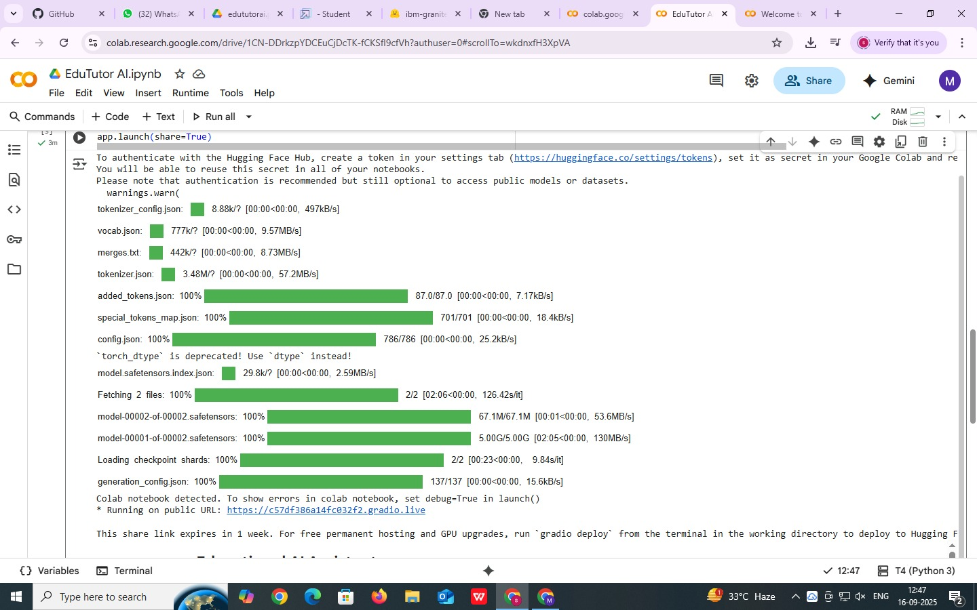Screenshot:

Below is a sample screenshot of the EduTutor AI Project Interface:

